Drug Trafficking in Australia
Student’s Name + Number
Professor’s Name
Course Number
Institutional Affiliation
Date

Drug Trafficking
The illicit drug trade, also known as drug trafficking, is a worldwide black market devoted to producing, manufacturing, distributing, and selling controlled substances. Most states use drug prohibition laws to ban the trade in certain forms of narcotics unless under license. Illegal drug use is common globally, and local authorities are finding it difficult to combat its popularity. Drug trafficking is commonly viewed as a significant crime by politicians all over the world. The type of substance, the amount trafficked, where the drugs are sold, and how they are delivered are all factors that affect the penalties. If the drugs are marketed to minors, the penalty for drug trafficking can be more severe than in other cases.
Free trade has aided financial market integration, providing drug smugglers more ways to launder money and invest in other ventures. This benefits the opioid industry while undermining law enforcement attempts to track drug money entering the legal economy (Astorga & Shirk, 2010). Cartel cooperation broadens their reach to new markets and improves their ability to avoid local law enforcement detection. Furthermore, criminal groups cooperate in organizing money-laundering operations by making different organizations manage particular phases of the laundering process. One criminal organization designs the process of how financial transactions can be laundered, while another criminal group offers the "dirty" money to be washed.
Drug trafficking in Australia
China, India, Southeast Asia, and the Americas are major departure points for drugs destined for Australia, with most of the trafficking taking place across countries and territories in the South Pacific, similar to Australia. This is made possible mainly utilizing yachts, fishing vessels, and cargo ships. Methamphetamine, more generally known as speed or ice, and cocaine and heroin, are the main narcotics smuggled into Australia by sea. Outlaw biker gangs in Australia, Mexican drug cartels in Mexico, Asian drug syndicates in Asia, and smaller crime rings all engage in this activity. Owing to the high price of narcotics and high demand for drugs in Australia, it is seen as an enticing destination for criminal organizations involved in maritime drug trafficking. In Australia, a kilogram of methamphetamine costs about 80 times as much as it does in China. In Sydney, a kilogram of cocaine would cost about 250,000 Australian dollars, while in Texas, it would cost $16,000.
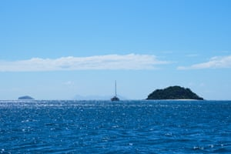
A ship sailing in Fiji waters, a commonly used route by traffickers.

Methamphetamine
Methamphetamine is a Schedule 8 drug in Australia, which means it is available for medicinal use but is limited in its production, delivery, and possession. Many people in Australia use it to get a 'high' or a 'rush' in their bodies. When the brain is filled with monoamines, users of this drug also experience exhilaration and arousal. As of April 2017, Australia had the world's highest rate of methamphetamine abuse (Hughes et al., 2020).
Between 2013 and 2014, the number of drug offenses in Australia rose by more than a quarter of a million, to about 50,000. This reflects an upward trend in substance use and drug-related crimes in Australia. However, as methamphetamine has become more widely available in Australia, it has evolved stronger forms, such as Crystal Methamphetamine, which has led to an increase in its use over the last decade. Despite a decrease in usage of methamphetamine between 2007 and 2010, especially among males, the rates have gone back up since 2010 (Hughes et al., 2020).
In a study titled Alcohol, tobacco, and other drugs in Australia, released in 2020 by the Australian Institute of Health and Welfare, Australia was found to have the fourth-highest average overall stimulant intake compared to 29 countries Europe, North America, Oceania, and South Africa. The study also discovered that the number of deaths involving methamphetamine and other stimulants had increased rapidly, with the death rate in 2018 is four times higher than in 1999. It's the second drug requiring concern after alcohol.
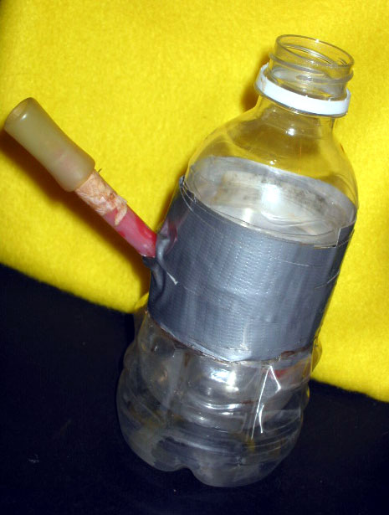
A meth bong.
Methamphetamine use is a growing issue in Australia as it becomes more readily available. In a survey of injecting drug users, the greater percentage indicated that methamphetamine was their first drug injected into their bodies; nevertheless, the study revealed that it is a young adults' drug. Methamphetamine was used by 87 percent of injecting drug users under the age of 25, 80 percent of those aged 25 to 35, and 74 percent of those aged 35 and up (Stoneberg et al., 2018). Methamphetamine manufacture and use continue to pose significant challenges for Australia, primarily because it is simple to produce, extremely addictive, and can have severe consequences for human health and the environment.
Although outlaw motorcycle gangs have long dominated Australia's methamphetamine market, there is no more contact between these groups and Chinese organized crime groups. China accounts for 70% of methamphetamine detections between 2011 and 2016. Australia's increased targeting as a gateway for drug traffickers has resulted in further actions by law enforcement agencies such as the Australian Border Force and the Australian Federal Police (Stoneberg et al., 2018). An example is a massive, complicated bust in Geraldton, Western Australia, where 1.2 tonnes of the drug were confiscated, valued at 1.04 billion Australian dollars, just a year after 182 kilograms of methamphetamines were seized at the same port. Although the drugs were bound for Australia's East Coast, Geraldton seemed to have been chosen as the first stop due to its remote location and limited seasonal fishermen population.
A drug bust in January 2019 at the Port of Los Angeles-Port of Long Beach intercepted 1,728 kilograms of methamphetamine with a street value of A$1.29 billion bound for Australia concealed inside loudspeakers. This bust also uncovered new connections between Australian biker gangs and Mexican drug cartels, confirming that Mexican cartels aggressively targeted Australia.

Cocaine
Cocaine is another drug gaining popularity among Australian drug users, with cocaine seizures on the rise. The bulk of cocaine comes from South and Central America. Much of it is smuggled into Australia from island states in the South Pacific, where cocaine-trafficking cartels have set up shops to import cocaine into Australia. Countries like Fiji are caught in the middle. Vanuatu, Papua New Guinea, Tonga, and New Caledonia are among the countries whose waters and beaches are being used to store billions of dollars worth of illegal drugs (Aziani, 2018).
In 2011, Australian Federal Police intercepted 700 kilograms of cocaine smuggled on a yacht, followed by another 750 kilograms in 2013. Cocaine, on the other hand, is smuggled into Australia through freight, the postal system, and couriers. With record prices in Australia, it's no surprise that Mexico's cartels are targeting the country (Aziani, 2018). While a kilogram of cocaine sold in the United States still generates a profit for the cartel, the same kilogram sold in Australia carries a large premium.
In recent years, Australia has seen several prominent maritime cocaine busts. In 2004, police in Vanuatu intercepted 120kg of cocaine on a beach, dubbed "the largest such haul in the Pacific nation's history" by the AFP. Police made a bust nine years later involving more than six times this number. In 2017, a yacht with 1.464 tonnes of cocaine concealed in its hull was intercepted near New Caledonia, and another boat with more than 1.4 tonnes of cocaine on board was stopped just off Australia's east coast. Each of these shipments was valued at more than $US200 million. This was thanks to the New South Wales Police Force's combined efforts, Australian Criminal Intelligence Commission, Australian Federal Police, and Australian Border Force.

Heroin

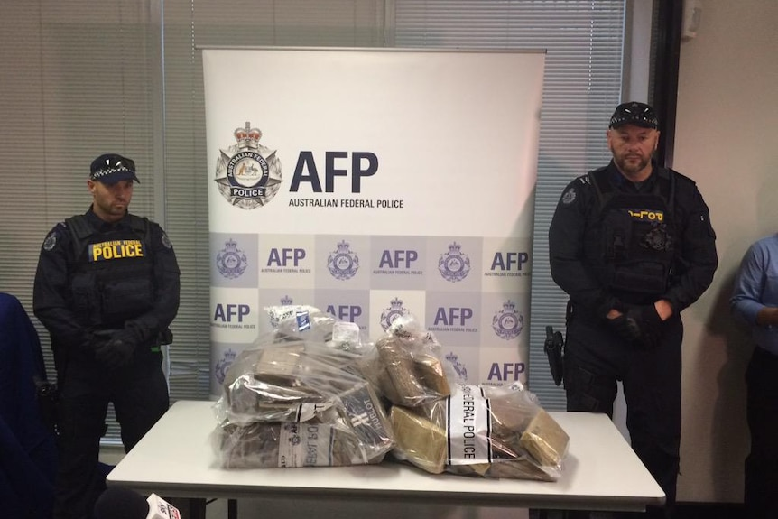

Heroin was confiscated from a drug lord by the AFP.

Heroin has a long history in Australia, with opiates being widely used in the nineteenth century until being outlawed in the mid-1950s. However, after the Vietnam War, the heroin market grew, resulting in many heroin users and an increase in overdose deaths in the 1980s and 1990s. While planes were previously used, heroin smugglers started to use modified steel-hulled vessels to transport the drug to Australia in the 1990s. Between 2006 and 2016, most of the heroin used came from the Golden Triangle, including Myanmar and the Lao People's Democratic Republic, and the Golden Crescent, which includes Pakistan and Afghanistan.
Even though heroin use in Australia has not reached previously unheard-of levels, the number of heroin detections increased between 2012 and 2013. Examining maritime heroin trafficking to Australia reveals South Pacific island territories and states' vulnerability, with most of it moving through pacific island states and territories such as Fiji, Vanuatu, and New Caledonia. In 2003, a North Korean cargo ship was accused of smuggling 125 kilograms of heroin into Australia, causing the US government to announce that state-sponsored drug trafficking is highly likely.
Crime gangs are steadily targeting the Pacific's most vulnerable states and territories to transport drugs to the Australian market. Many of these countries lack anti-trafficking capabilities, limiting their ability to police their waters independently. The United Nations drug control convention in the area is only ratified by Fiji, Tonga, the Marshall Islands, and the Federated States of Micronesia as of 2016. Besides, many drug-related laws in the area are out of date, such as those prohibiting the use of synthetic drugs. Due to financial constraints, the transnational Pacific Drug and Alcohol Study Network has been inactive since 2011. Pacific law enforcement agencies function in relative isolation while fighting criminal organizations with sophisticated transnational networks.
Because of the post-9/11 focus on terrorism, there are gaps in investigation and intelligence to tackle new, increasingly sophisticated transnational criminal networks. To increase their resiliency, these cartels have expanded their operations to include a wide range of narcotics and other activities such as human trafficking and extortion.
Several push and pull factors can help to explain the existence of Mexican cartels in Australia, with lower demand for cocaine coupled with higher profits seen in operating in Australia or Europe contributing to these cartels spreading out away from only Mexico, with Australia having some of the world's highest drug prices while also having a strong demand from drug use. Chinese criminal gangs are also involved in maritime methamphetamine trafficking to Australia, working with Australian outlaw motorcycle gangs. A large percentage of methamphetamine intercepted at the border originates in China.
Mitigation measures
With several transnational cooperation efforts and joint organizational busts, Australia has attempted to tackle maritime drug smuggling into Australia through law enforcement, naval powers, and strategy. The Australian Navy makes it a priority to fight maritime crime, both on its own and through transnational alliances and groupings. This involves anti-narcotics efforts. Operation Slipper, the Australian Defense Force's contribution to an international campaign against drug trafficking, piracy, and terrorism in the Indian Ocean, included the now decommissioned warship, HMAS Darwin.
This not only acted as a deterrence and surveillance capability, but it also yielded concrete results, as demonstrated by the seizure of the world's largest heroin haul at sea in 2014 in partnership with the Royal Navy. As part of a broader international campaign to fight terrorism, HMAS Arunta has been deployed to Africa's East Coast to disrupt drug money flow to terrorist groups. According to the United Nations, the drug trade is estimated to account for more than half of the Taliban's profits. Of course, the federal police also played a crucial role in responding to maritime drug trafficking into Australia, with several busts, including the cocaine busts in the South Pacific crackdown, involving them.
The National Ice Taskforce's national plan aims to minimize the ice (methamphetamine) crisis in Australia, as does the Australian government's pledge in July 2016 to spend nearly A$300 million over the next four years on educational, preventative care, and community involvement programs to tackle methamphetamine. The A$293 million budget allocation for airport security and cargo screening in 2018 is also a response and possible deterrent to would-be drug smugglers targeting Australia.
There's also the possibility that Australian authorities will try to fight maritime drug smuggling by repurposing resources that would otherwise be used for other purposes, effectively extending existing programs or organizations' roles. This could become a more common trend in the South Pacific due to the aforementioned lack of capabilities. The Forum Fisheries Agency (FFA) in Honiara, Australia, is a member, is an example of this. The FFA surveillance center maintains an eye on up to 30 million square kilometers of ocean, including the exclusive economic zones (EEZs) of 15 island nations (excluding Australia and New Zealand). Although this is done to secure tuna fishing license revenue, its activities can be expanded to detect drug smuggling and other related concerns such as people smuggling at a marginal cost increase.

References
Astorga, L., & Shirk, D. A. (2010). Drug trafficking organizations and counter-drug strategies in the US-Mexican context.

Hughes, C. E., Chalmers, J., & Bright, D. A. (2020). Exploring interrelationships between high-level drug trafficking and other serious and organised crime: an Australian study. Global Crime, 21(1), 28-50.
Aziani, A. (2018). Data and Assumptions Behind the Application of the Flow-Network Approach to the Cocaine Trafficking. In Illicit Financial Flows (pp. 63-104). Springer, Cham.
Stoneberg, D. M., Shukla, R. K., & Magness, M. B. (2018). Global methamphetamine trends: an evolving problem. International criminal justice review, 28(2), 136-161.

